Kelsey Caswell
ENG5307.001
Dr. Zhu
17 September 2024
Evaluation and Critique of Gestalt Principles Applied to a Technical Document:
Tesla’s Cybertruck Owner’s Manual Website
Introduction
Gestalt Theory states that “people perceive a structure of components that they treat as a whole of “gestalt”” (Moore and Fitz 390). This theory was developed using psychological evaluation of viewers perception of individual elements, and seeing what conglomerative image they could create. This theory established six principles, named Gestalt Principles, that help to guide design elements so that the creators of visual content have a better understanding of how to make their documents the most effective. According to Moore and Fitz’ article, Using Gestalt Theory to Teach Document Design and Graphics, the six Gestalt principles are figure-ground segregation, symmetry, closure, proximity, good continuation or continuity, and similarity.
To better understand Gestalt principles, and their place in technical communications by looking for the usage of them within a technical document, I will be evaluating the owner’s manual webpage for Tesla’s Cybertruck. First and foremost, the target audience for the Cybertruck must be considered, that way the application of Gestalt principles can be understood.
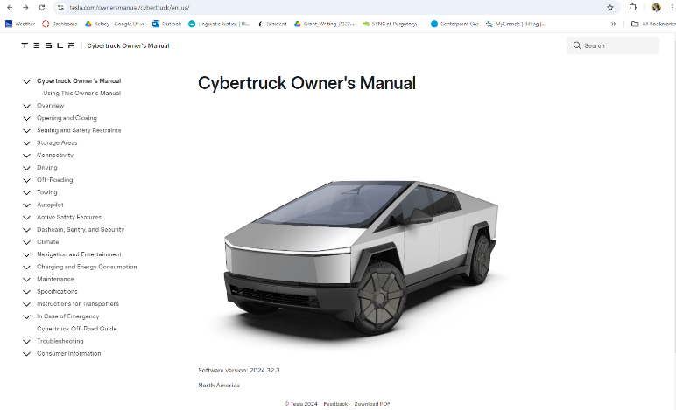
This target market includes “high-income earning upper-middle class” (PDFAgile 2021) individuals who are interested in sustainable environmental practices that are also interested in emerging technologies. Because the price of the Cybertruck ranges from $93,990-129,990 (Tesla 2024), the target audience has to have a large amount of disposable income. Of members of the upper-middle class, Telsa specifically targets those who “are also tech-savvy, trendy, fashionable, and sophisticated” (PDFAgile 2021) that “actively seek out premium quality” (PDFAgile 2021). With this understanding, we can assume that the Gestalt principles that are applied would need to create an overall feeling of clean sophistication, luxury, and exclusivity within the document. I believe that to evaluate the success of this website’s guide, and to see where its failings lie, the main Gestalt principles of symmetry, figure-ground, and similarity to be evaluated.
Figure 1 – Tesla Cybertruck Owner’s Manual website homepage
Symmetry

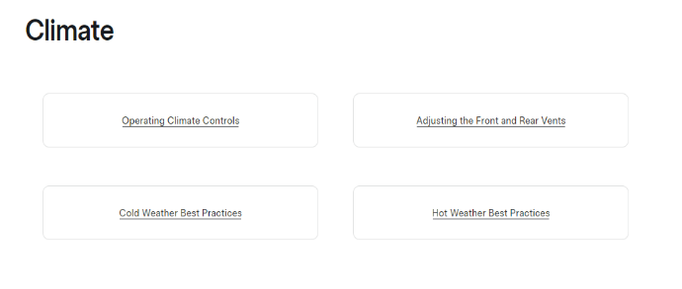
Figure 2 shows just one example of symmetry seen within the Cybertruck Owner’s Manual website. This is one section of the page, divided symmetrically into 4 quarters. This creates a flow that is easy for the viewers eyes to follow and gives a feeling of stability. This aids in increasing the feeling of Tesla as a stable and professional organization, because the symmetrical layout throughout this section “provides a clear path through the information” (Moore and Fitz, 391) as is needed to create a symmetrical document. The simple, minimalistic layout of this section creates a sophisticated feel in the content.
Figure 2 - Cybertruck Manual Subpages
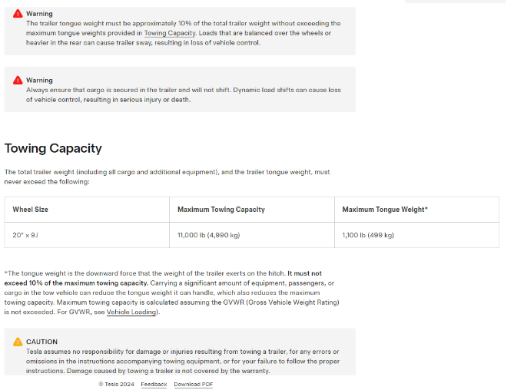
Figure 3 shows an example of poor symmetry seen within the Cybertruck Owner’s Manual website. This screenshot shows the webpage at a regularly sized window, not magnified or reduced, and that the table underneath the “Towing Capacity” section protrudes from the rest of the content, setting the reader on edge and running the consistency throughout the document. I have to wonder if there was a purpose for this. Is this asymmetry purposeful or is it an oversight? It is possible that a brand spearheaded by someone as controversial as Elon Musk would create a document with elements that go against standard principles. It is important to understand the audience and brand, that way each thing could be evaluated
Figure 3 - Cybertruck Manual Towing information with poor symmetry
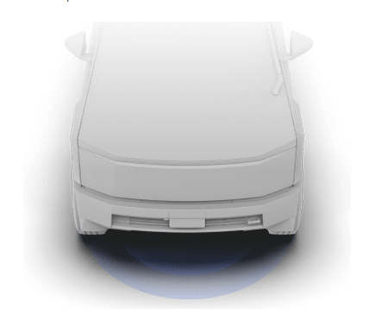
Figure-Ground Segregation
Figure 4 - Cybertruck Manual Image of Sensor
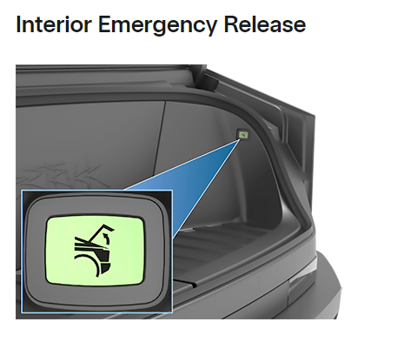
In Figure 4, there is a figure, presumed to be of the Cybertruck on a plain, white background. Because this is representing the awareness underneath the car, and without the separation between the figure and the background it would be unclear what information is being communicated. With that being said, the use of blue against the white and light greys on the Cybertruck Owner’s Manual website is subtle enough to not detract from the clean and sophisticated aesthetic but is colorful enough to show that there are sensors. “With the wider availability of color today, document designers must be careful to make sure that their colors contrast sufficiently so that the figure can be readily distinguished from the ground” (Moore and Fitz, 391). I do believe that there could be more color contrast within the Figure 4 image, even using a deeper range of grays to distinguish the shapes would give more definition to follow the Gestalt Principle of Figure-Ground. Figure 5 shows the well-defined image against a plain background.This gives more definition and is clearer is its boundaries of what is in the background and what image is perceived to be in the foreground. Overall, the Cybertruck Owner’s Manual website has many images with this sort of Figure-Ground orientation, leaving them stand-alone on the page rather than leaving them in an environment
Figure 5 - Cybertruck Manual Image with more contrast
Similarity
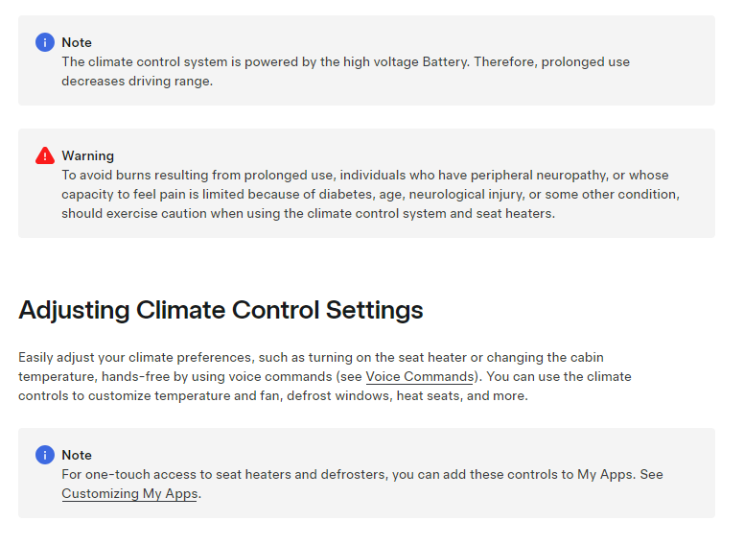
Throughout the website, each page has design elements that resemble each other and draw attention. In Figure 6, the symbols marking Note and Warning are clear to see, and are used throughout the document, but keeping those images the same, a person who is skimming through the manual while looking for one specific note or warning will be able to easily identify it by nothing the symbol’s similarities in usage.
Figure 6 - Image of Note and Warning Symbols
“Changes in spacing, typesize, or typestyle suggest a change in subject matter, emphasis or focus” (Moore and Fitz 400). By avoiding making these changes, there is an understanding that all of the content on the website and its subpages will have the same subject matter. By keeping all of the relevant content in a similar style throughout this owner’s manual websites, as well as all other Tesla owner’s manuals websites, this builds trust with the target audience.
To be critical of the lack of similarities, the design style of the images as seen in Figure 4 and Figure 5, there is no singular style of images in the content. This suggests that the creators of the images were either different or had different standards when adding the images to the manual. This decreases the perceived stability in the brand and the quality of the document.
Conclusion
Overall, following Gestalt principles does create more complete and enriched documents that are able to tell a story with their visual elements. The Tesla Cybertruck Owner’s Manual has many good elements that prove that the document has been designed for its intended audience with much care, but there are areas that need to be improved upon to create a more complete document.

Works Cited
“Cybertruck Owner’s Manual.” Tesla, www.tesla.com/ownersmanual/cybertruck/en_us/. Accessed 8 Sept. 2024.
Moore, Patrick, and Chad Fitz. “Using Gestalt Theory to Teach Document Design and Graphics.” Technical Communication Quarterly, vol. 2, no. 4, Sept. 1993, pp. 389–410. https://doi.org/10.1080/10572259309364549.
“Tesla Segmentation, Targeting, and Positioning.” PDF Agile, www.pdfagile.com/blog/tesla-segmentation-targeting-and-positioning. Accessed 8 Sept. 2024.

