
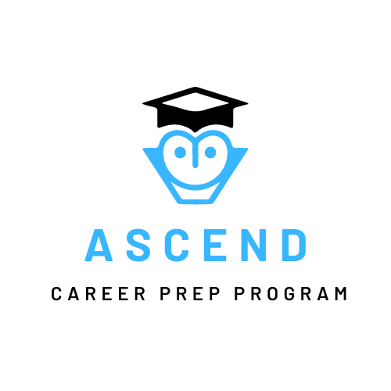
MEDIA KIT

HELPING STUDENTS FIND THEIR PASSIONS

ASCEND.ORG
555-555-5555
PR@ASCEND.ORG

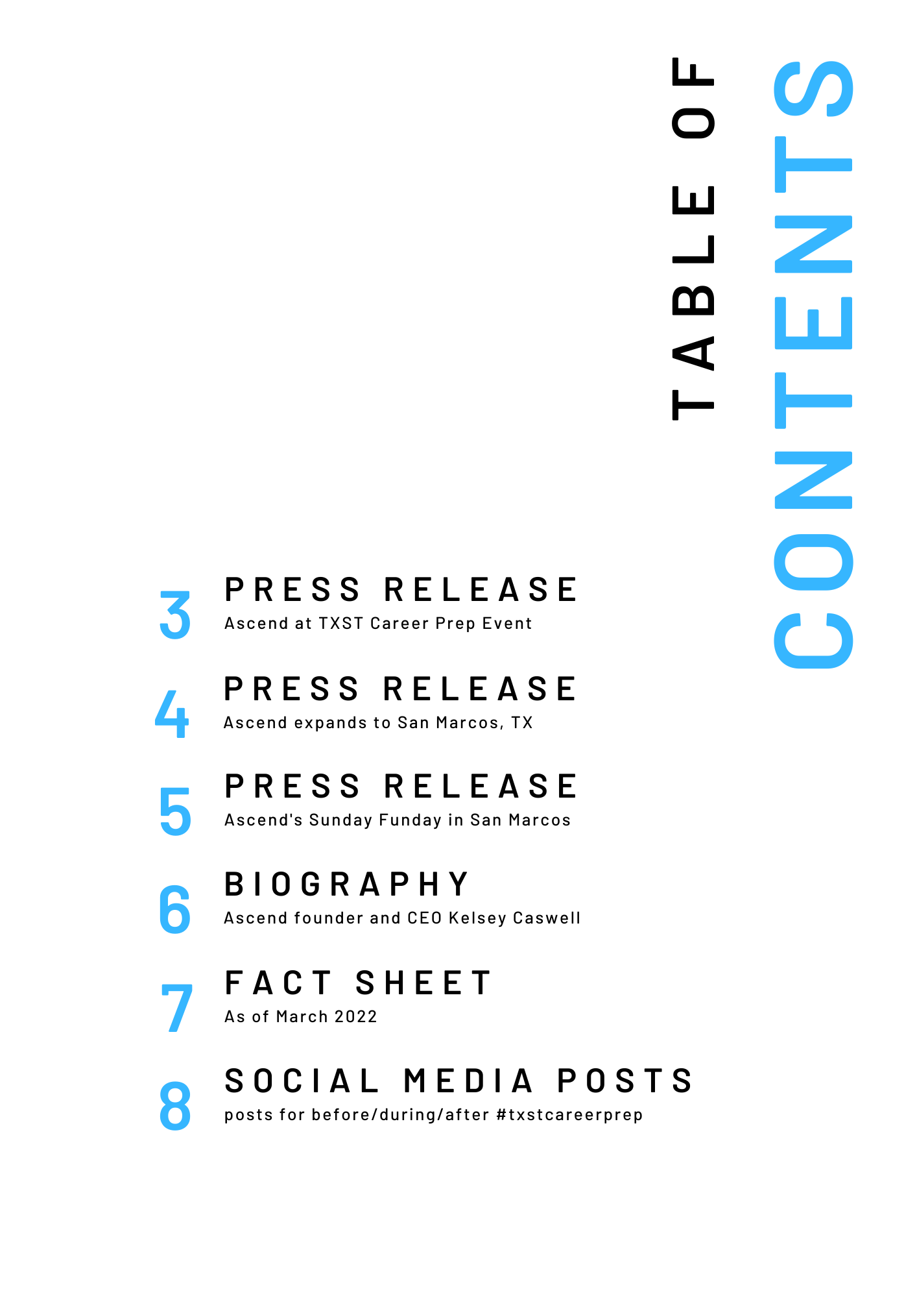

FOR IMMEDIATE RELEASE

April 20, 2022
Contact: Kelsey Caswell
Agency: Ascend
Telephone: 555-555-5555
Email: kelsey.caswell@ascend.org

Ascend featured at Texas State University career prep event
(SAN MARCOS, Texas) – Ascend will be present at the Texas State University career preparation event on May 4 from 1 p.m.- 5 p.m. in the LBJ Student Center Grand Ballroom.
Ascend is seeking to hire four new public relations specialists from Texas State University as well as two public relations interns for the fall semester. These new hires will be given the opportunity to work with Ascend’s partners such as Tesla, Apple, and Amazon to develop strategic messages relating to ongoings of the non-profit.
Texas State University alumna and Ascend founder and CEO, Kelsey Caswell, will be attending the event to give insight into the public relations operations and efforts of Ascend.
“As a former bobcat, I feel the need to visit my alma mater and share Ascend’s journey,” says Caswell. “I also think that it’s extremely fitting that a career prep program will be featured at the career prep fair. This will give us the opportunity to share what it really takes to be successful in the career world and the non-profit industry.”
Ascend’s station at the event will be showing sample career counseling sessions and learning labs through virtual reality headsets. Ascend employees at the station will be answering questions about behind the scenes operations.
For more information, visit ascend.org/careeropportunities or visit Texas State University’s career services website at https://www.careerservices.txstate.edu/
###
Ascend is an afterschool education program that partners with school districts, corporations, and other nonprofit organizations to give students the opportunity to learn about different career fields to help spark passion for their futures

FOR IMMEDIATE RELEASE
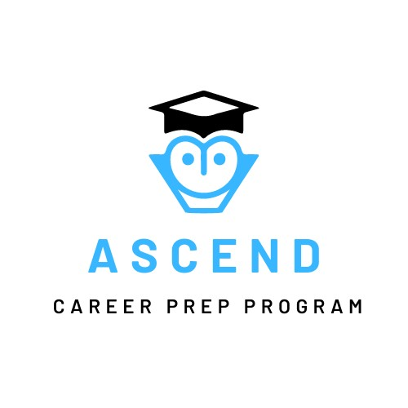

March 1, 2022
Contact: Kelsey Caswell
Agency: Ascend
Telephone: 555-555-5555
Email: kelsey.caswell@ascend.org
Ascend expands to San Marcos
(SAN MARCOS, Texas) Ascend Career Prep Program has opened a new Learning Lab in San Marcos, Texas. Students from San Marcos, and surrounding areas, will be able to attend this afterschool program starting in the fall of 2022.
“We are thrilled that Ascend has chosen San Marcos as the newest location of their program,” says San Marcos CISD Superintendent Michael Cardona. “We know that this program will create countless opportunities for all students to learn valuable information about any career field they are interested in.”
As of 2021, Ascend has over 30,000 Learning Lab locations in the United States. Each location is the result of a partnership with a school district and takes place after hours within the school building. The San Marcos Learning Lab will be hosted inside of San Marcos High School.
Ascend is made possible through donations and grants. To become a donor or inquire about opening a new Learning Lab location please contact Kelsey Caswell at 555-555-5555 or visit https://kecaswell2001.wixsite.com/ascend
###
Ascend is an afterschool education program that partners with school districts, corporations, and other nonprofit organizations to give students the opportunity to learn about different career fields and spark passion for their futures.

FOR IMMEDIATE RELEASE

April 1, 2022
Contact: Kelsey Caswell
Agency: Ascend
Telephone: 555-555-5555
Email: kelsey.caswell@ascend.org
Ascend brings Sunday Funday tradition to San Marcos
(SAN MARCOS, Texas) – Ascend will be hosting a 5K race and festival in order to fundraise for the newest location in San Marcos. Sunday Funday will take place on Sunday, April 10th at Five Mile Dam Park.
Ascend’s Sunday Funday is a traditional event hosted after the launch of a new branch of the after school program. The day will include a 5k race, a raffle with $10,000 worth of donated prizes, an outdoor game tournament, complimentary meals throughout the day, and live music by local bands played all day. Sunday Funday is open to the public, and tickets are available for $5 at the gate and on Ascend’s website.
A pre-race breakfast and beverage bar will be served beginning 7 a.m. The first wave of racers will be sent off at 8 a.m. and the following waves will be sent off in five-minute increments. Music, free food, and games will begin at 9 a.m. Three different raffles will be drawn at 11 a.m., 2 p.m., and 4 p.m. Donations will be accepted throughout the day at the ticket sales table.
For more information, to register to race, or to donate, please visit smtxascend.org or contact Kelsey Caswell at 555-555-5555
###
Ascend is an afterschool education program that partners with school districts, corporations, and other nonprofit organizations to give students the opportunity to learn about different career fields to help spark passion for their futures.

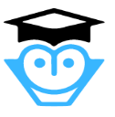
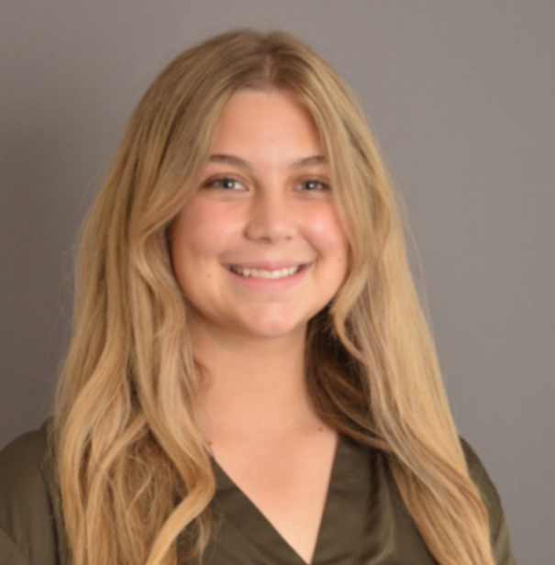
BIOGRAPHY
In August of 2005, Ascend Founder and CEO, Kelsey Caswell began college at Texas State University. She noticed that when many of her fellow students were asked what they wanted to do with their lives, they all had the same answer.
“I DON’T KNOW.”
Not knowing was fine. College was the time for figuring things out, students could study what they wanted, and worry about making money later.
Then the 2008 recession began, and all of sudden jobs were few and far between, and students had to know their answer. Classes became smaller, and people no longer had the luxury of taking their time to figure out their passions. More and more of Kelsey’s classmates dropped out of college to find work or finished with majors that they didn’t care about in order to find jobs. Kelsey was fortunate enough to have had afterschool organizations throughout K-12 that helped her to find a passion for entrepreneurship. She began to wonder what would happen if students had exposure to the same career education that she had. Would less of her classmates be forced to settle? Would less people be forced into jobs and careers that they didn’t care about? And those thoughts led to an idea of a better world..
Ascend Founder and CEO Kelsey Caswell
Telephone: 555-555-5555
Email: Kelsey.caswell@ascend.org
A world where all students are able to find their passion for life after graduation through career exploration and education.
Thus, the first Learning Lab was created, and Ascend has since become the nation’s largest and most successful career preparation program.

Creation
Founded in January of 2009 by philanthropist, Kelsey Caswell, Ascend has quickly become the fastest growing afterschool program in the nation.
Milestones
As of 2021, Ascend has opened locations in all 50 states. In October of 2021, locations opened in Hawai'i, North Dakota, and Maine, making Ascend available to students all across America.
AS OF MARCH 2022

Mission
Ascend seeks to provide career-based education to students from all backgrounds through afterschool education. Ascend encourages students to learn without limits, lead without fear, and live above the expectations of the world.
For More Information:
Contact: Kelsey Caswell
Agency: Ascend
Telephone: 555-555-5555
Email: Kelsey.caswell@ascend.org

Services
Ascend is able to function through the use of two major services:

Learning Lab
The physical area where students will be learning after school. These typically take places in computer lab, classroom, or outdoors. Material is taught from computers provided by Ascend.
Ascend Counseling
Career and academic advice given to students from thoroughly trained advisors, that is proven to help students find their way after high school graduation

Key Executive
Kelsey Caswell is the founder and CEO of Ascend Career Prep Program. During her time in college, she noticed that many students struggled when it came to picking majors that they were passionate about, which resulted in students leaving school. This sparked an idea. What if all students were given the opportunity to learn about the career field? And with that idea, she launched Ascend
Partners
Ascend's partnerships provide in depth education into the operations of many successful companies
-Tesla
- Apple
- Boeing
- Amazon
- PepsiCo
- Penguin RandomHouse
- Mattel
- American Airlines
- Macy’s
- Chevrolet
- Shell Oil
- Wal-Mart
Donors
In the past year, Ascend has received generous donations from philanthropists such as Mackenzie Scott, Dolly Parton, Bill and Melinda Gates, Julie Andrews, and Warren Buffett



